**WEEKLY LOG**

**(every Sunday)**



**Sprint 1 (4.11)**

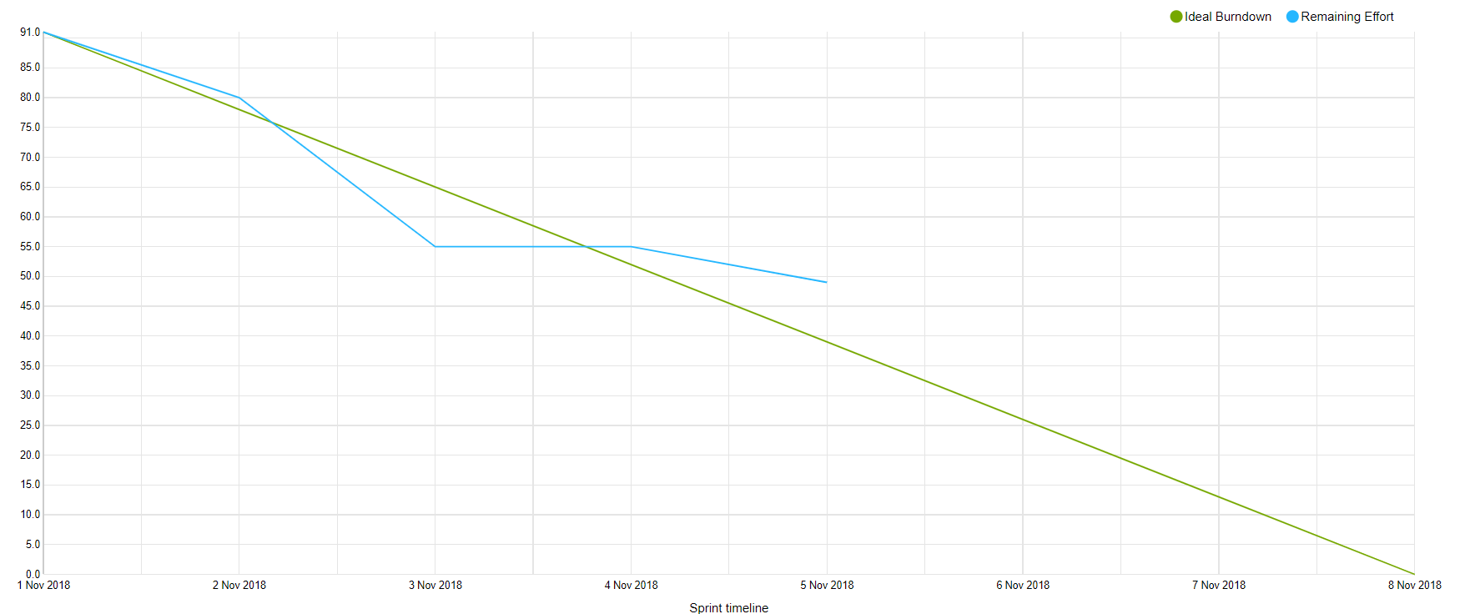

**What is done:**

* Database server
* Communication protocol (Search/Advanced search)
* Bookstore/Library implementation of model
* Activity diagram searching
* Class diagram : model, bookstore, library
* EER diagram : database book
* Database structure for books
* Domain and Logical model of book
* Search engine on database server

**What is in progress:**

* Class diagram : book service
* Book service redirecting and gathering book quieres
* GUI : search page (main page)
* GUI : showing results on web site
* Library/Bookstore connect to database
* Library expose REST for searching the book (just tests are missing)